**MIT School of Engineering**

**Department of Computer Science and Engineering**

**Project Synopsis**

**Group ID: 07**

**Project Title: Cancer Detection using Machine Learning**

**Group Members:**

|  |  |  |  |  |
| --- | --- | --- | --- | --- |
| **Enrollment Number** | **Roll Number** | **Name of student** | **Email Id** | **Contact Number** |
| MITU20BTCS0111 | 2203076 | Harshal Jadhav | Jadhav.harshal592002@gmail.com | 78755 96063 |
| MITU20BTCS0199 | 2203088 | Pranav Deshpande | Pranavdeshpande112@gmail.com | 8421005052 |
| MITU20BTCS0236 | 2203402 | Rohit Khare | rokhare2002@gmail.com | 99229 58850 |

**Problem Statement:**

This project aims to compare various machine learning algorithms using cancer diagnosis datasets to identify the most effective approach by pinpointing the highest accuracy, reliability, and generalization; ultimately supporting healthcare professionals in making more precise and timely cancer diagnoses.

Aim is to implement XAI ( Explainable AI ) framework to existing project to better understand weights and biases related to the various algorithms and how they react with the data.

**Abstract:**

Cancer is a global health concern, demanding early and accurate diagnosis for effective treatment. Leveraging the power of machine learning, this project addresses the challenge of algorithm selection for cancer diagnosis. We systematically compare diverse machine learning algorithms using cancer diagnosis datasets to pinpoint the most reliable and accurate solutions. Our research aims to enhance the diagnostic process, ultimately benefiting healthcare professionals and patients alike. By evaluating algorithm performance, this project contributes to the advancement of cancer diagnosis, promising better patient outcomes and more efficient healthcare systems.

**Literature Survey:**

|  |  |  |  |
| --- | --- | --- | --- |
| Serial number | Name of the paper | Authors | Remarks |
| 1. | Breast Cancer Detection Using Machine Learning Algorithms," 2018 International Conference on Computational Techniques, Electronics and Mechanical Systems (CTEMS) | S. Sharma, A. Aggarwal and T. Choudhury | The Wisconsin Diagnosis Breast Cancer data set was used as a training set to compare the performance of the various machine learning techniques in terms of key parameters such as accuracy, and precision. |
| 2. | Comparative analysis of breast cancer detection using machine learning and biosensors | Yash Amethiya, Prince Pipariya, Shlok Patel, Manan Shah | The objective of this review was to present several approaches to investigate the application of multiple algorithms based on machine learning (ML) approach and biosensors for early breast cancer detection. |
| 3. | Accuracy Assessment of Machine Learning Algorithms Used to Predict Breast Cancer | [Ahmed Ahmed, Hesham Sedky](https://sciprofiles.com/profile/2675759?utm_source=mdpi.com&utm_medium=website&utm_campaign=avatar_name),  [Saleh Mesbah](https://sciprofiles.com/profile/1782262?utm_source=mdpi.com&utm_medium=website&utm_campaign=avatar_name) | Machine learning (ML) is the scientific study of algorithms and statistical models that computer systems use to perform a specific task without being explicitly programmed. Learning algorithms in many applications |

**Proposed System (Block Diagram):**

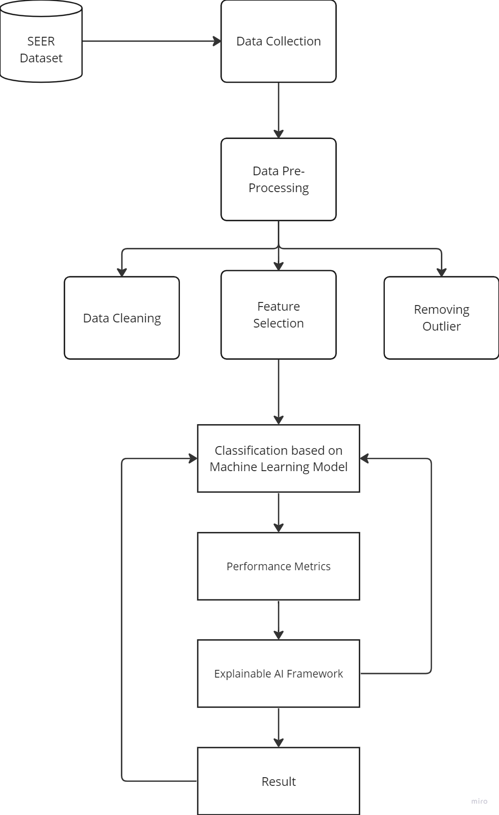

**Conclusion:**

In this project, we undertook a comprehensive examination of various machine learning algorithms using cancer diagnosis datasets. The objective was to determine the most effective algorithm for enhancing the accuracy and reliability of cancer diagnoses. Through rigorous analysis, we shed light on the strengths and weaknesses of different approaches, ultimately providing valuable insights for healthcare professionals and the broader medical community.

We demonstrated that certain algorithms exhibit superior performance in terms of accuracy, reliability, and generalization, offering the promise of more timely and precise diagnoses.

**References:**

<https://www.mdpi.com/2306-5729/8/2/35>

<https://www.sciencedirect.com/science/article/pii/S2667102621000887>

<https://www.sciencedirect.com/science/article/pii/S2667102621000887>

**Annexure:**

**Annexure I: Form A-Title Approval (for offline mode)**

**Annexure II: Form B-Market and financial feasibility (verify from guide)**

**Annexure III: Literature survey paper or links**